**PIZZA SALES SQL QUERIES**

**A. KPI’s**

**1. Total Revenue:**

SELECT SUM([total_price]) AS 'Total_Revenue'

FROM pizza_sales;

**2. Average Order Value**

SELECT SUM([total_price]) / COUNT(DISTINCT([order_id])) AS 'Average_Order_Value'

FROM pizza_sales

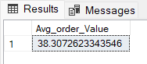

**3. Total Pizzas Sold**

SELECT SUM([quantity]) AS 'Total_pizza_sold'

FROM [dbo].[pizza_sales]

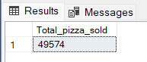

**4. Total Orders**

SELECT COUNT(DISTINCT([order_id])) AS 'Total_Orders'

FROM pizza_sales

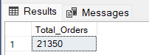

**5. Average Pizzas Per Order**

SELECT

CAST(

CAST(SUM([quantity]) AS DECIMAL(10, 2)) /

CAST(COUNT(DISTINCT [order_id]) AS DECIMAL(10, 2))

AS DECIMAL(10, 2)) AS 'Average_Pizz_pe_order'

FROM pizza_sales;

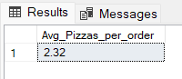

**B. Daily Trend for Total Orders**SELECT DATENAME(DW, [order_date]) AS 'Order_Day', COUNT(DISTINCT([order_id])) AS 'Total_Orders'

FROM [dbo].[pizza_sales]

GROUP BY DATENAME(DW, [order_date]);

***Output:***

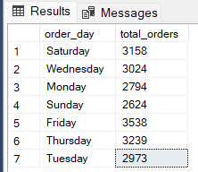

**C. Monthly Trend for Orders**

select DATENAME(MONTH, order_date) as Month_Name, COUNT(DISTINCT order_id) as Total_Orders

from pizza_sales

GROUP BY DATENAME(MONTH, order_date)***Output***

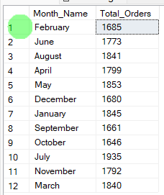

**D. % of Sales by Pizza Category**

SELECT

pizza_category,

CAST(SUM([total_price]) AS DECIMAL (10,2)) AS 'Total Revenue',

CAST(SUM([total_price]) * 100.0 /

(SELECT SUM([total_price]) FROM [dbo].[pizza_sales]) AS DECIMAL(10, 2)) AS 'Percentage of Sale by Category'

FROM [dbo].[pizza_sales]

GROUP BY [pizza_category];

***Output***

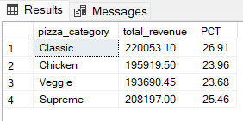

**E. % of Sales by Pizza Size**

SELECT [pizza_size], CAST(SUM([total_price]) AS DECIMAL (10,2)) AS 'Total_revenue',

CAST(SUM([total_price]) * 100 / (SELECT SUM([total_price]) from pizza_sales) AS DECIMAL(10,2)) AS 'Percentage of Sale by Pizza Size'

FROM [dbo].[pizza_sales]

GROUP BY [pizza_size]

ORDER BY [pizza_size] ASC;

***Output***

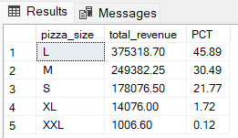

**F. Total Pizzas Sold by Pizza Category**

SELECT pizza_category, SUM(quantity) as Total_Quantity_Sold

FROM pizza_sales

WHERE MONTH(order_date) = 2

GROUP BY pizza_category

ORDER BY Total_Quantity_Sold DESC

***Output***

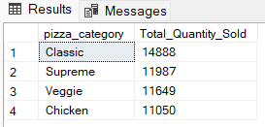

**G. Top 5 Pizzas by Revenue**

SELECT Top 5 pizza_name, SUM(total_price) AS Total_Revenue

FROM pizza_sales

GROUP BY pizza_name

ORDER BY Total_Revenue DESC

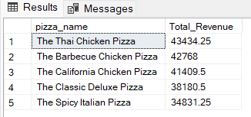

**H. Bottom 5 Pizzas by Revenue**

SELECT Top 5 pizza_name, SUM(total_price) AS Total_Revenue

FROM pizza_sales

GROUP BY pizza_name

ORDER BY Total_Revenue ASC

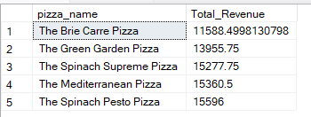

**I. Top 5 Pizzas by Quantity**

SELECT Top 5 pizza_name, SUM(quantity) AS Total_Pizza_Sold

FROM pizza_sales

GROUP BY pizza_name

ORDER BY Total_Pizza_Sold DESC

***Output***

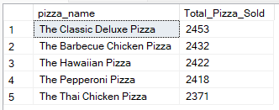

**J. Bottom 5 Pizzas by Quantity**

SELECT TOP 5 pizza_name, SUM(quantity) AS Total_Pizza_Sold

FROM pizza_sales

GROUP BY pizza_name

ORDER BY Total_Pizza_Sold ASC

***Output***

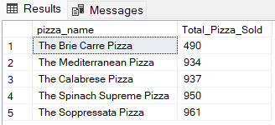

**K. Top 5 Pizzas by Total Orders**

SELECT Top 5 pizza_name, COUNT(DISTINCT order_id) AS Total_Orders

FROM pizza_sales

GROUP BY pizza_name

ORDER BY Total_Orders DESC

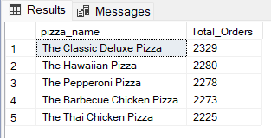

**L. Bottom 5 Pizzas by Total Orders**

SELECT Top 5 pizza_name, COUNT(DISTINCT order_id) AS Total_Orders

FROM pizza_sales

GROUP BY pizza_name

ORDER BY Total_Orders ASC

